Project Development Phase Model Performance Test

Date | 10 January 2026
Team ID | LTVIP2026TMIDS38170
Project Name | Hematovision: advanced blood cell  classification using transfer learning
Maximum Marks | 10 Marks

Model Performance Testing:
Project team shall fill the following information in model performance testing template.

S.No. | Parameter | Values | 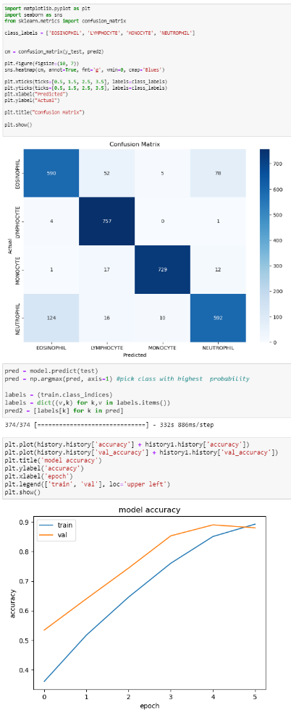  Screenshot
1. | Metrics | Classification Model:  Accuray Score- 0.893
2. | Tune the Model | Hyperparameter Tuning - The notebook primarily focuses on training the added dense layers with a pre-trained MobileNetV2 model (frozen base layers). Adam optimizer was used with categorical crossentropy loss. The training ran for 15 epochs, with the best validation accuracy observed around epoch 11.<br>Validation Method - A validation split of 0.2 was used during image data generation (validation_split=0.2).

